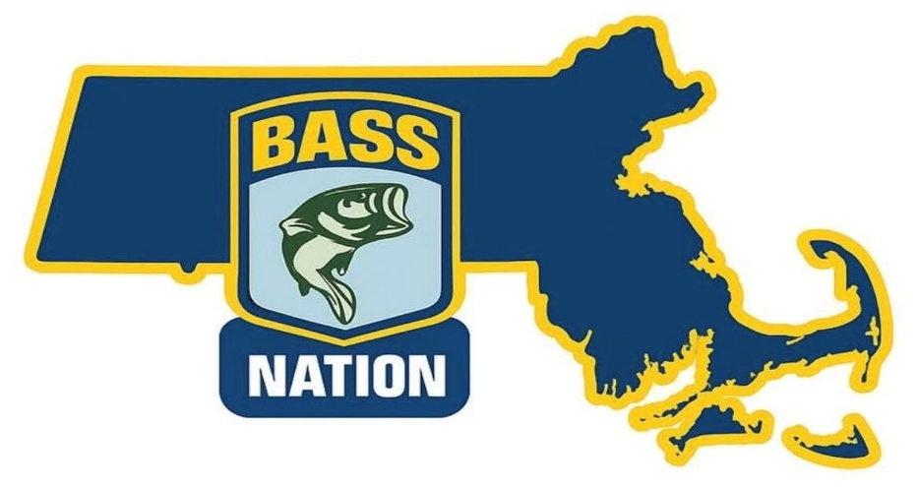

Bylaws for
Massachusetts B.A.S.S. Nation Kayak Anglers
Revised as of January 1, 2026

ARTICLE I – Name and Purpose
Section 1:
Name: This Club shall be called the Massachusetts B.A.S.S. Nation Kayak Anglers (MABNK)
Section 2: Purpose
To stimulate public awareness of kayak bass fishing. To grow the sport and expand the community of like-minded anglers while fueling our competitive spirit. To offer our state conservation department our organized moral and political support and encouragement to improve opportunities for kayak anglers of all ages. To function as a dynamic and effective link with other Clubs of the state B.A.S.S. Nation, embracing the principles and purposes of B.A.S.S.®.
ARTICLE II – Membership
Section 1: Number of Members
The Club shall begin with and maintain at least six members.
Section 2: Requirement for Regular Membership
To become a Club member, a person shall:
(a) Voluntarily express a genuine interest in membership.
(b) Be a member of B.A.S.S. (See ARTICLE VI for affiliation requirements.)
(c) Be a member of MA B.A.S.S. Nation.

(f) Be 18 years of age.

Section 3: Membership Dues
Must have a BASS membership in good standing before joining the club. The membership dues shall be $90 annually, initially payable upon joining the Club, $30 of which shall be for B.A.S.S. Nation dues, $35of which shall be for MA Bass Nation dues, and $25 of which shall be for MABNK Club dues. B.A.S.S. membership dues are also required at the current rate. (See ARTICLE VI, Section 1 for state affiliation requirements.)

ARTICLE III – Officers, Elections, Vacancies, and Eligibility
Section 1: Officers shall conduct the affairs of the Club in a manner consistent with these Bylaws. In addition, the State B.A.S.S. Nation Board of Directors is required to be comprised of members who are free to serve the State and its members without a conflict of interest. B.A.S.S. Nation State Board Members and Officers are not permitted to hold positions within any other B.A.S.S. Nation-type organization, that is not affiliated with B.A.S.S.
Section 2: Officers and their Duties
The officers of the Club shall consist of:
(a) President: Preside over all meetings and direct all official business. Appoint and be an ex-officio member of all committees. Supervise all club functions.
(b) Vice President: Act as program chairman, assist the president in his/ her duties and preside in the absence of the president.
(c) Secretary: Maintain accurate minutes of all regular and special meetings as called for by the Club president. Maintain regular liaison between your Club and the B.A.S.S. and the state B.A.S.S. Club.
(d) Treasurer: Collect and disburse all monies. Maintain accurate financial records and present a current balance report at each regular meeting. Prepare an annual audit for review by the Club board of directors. The Club may vote that the treasurer and any other officer handling Club funds must be bonded.
Section 3: Elections
The election of officers shall be held upon a motion and a second by members, the vote will be held at a members meeting during the month of December. The election shall be by a simple majority of members present. Election for each officer shall be held separately in the order listed in ARTICLE III, Section 2.
Section 4: Eligibility of Vote
Each member is entitled to one vote. Proxy votes are not permitted.
Section 5: Term of Office
The term of office is for one year, which shall begin on January 1 and end on the last meeting day of December or until the successor assumes office.
Section 6: Vacancies
In the event of an office becoming vacant, nominations shall be asked for and an election held to fill the unexpired term of the individual vacating the office. National B.A.S.S. headquarters shall be notified immediately of the change of any officers.
Section 7: Eligibility for Holding Office
To be eligible for an office a member must:
(a) Have been a member for six months. (Six months’ requirement waived during first 12 months of Club existence.)
(b) Have attended at least 75% of the Club meetings and 75% of Club functions during a 12-month period.
(c) Have shown an active interest in all Club functions.
(d) Maintain current B.A.S.S. membership.
ARTICLE IV – Standing Committees
All standing committees will serve for one year or until a new committee is appointed. The terms of the committee members will coincide with that of the president. Each committee shall elect a chairman.
(a) Board of Directors: The board of directors will consist of no less than three, no more than seven members. The board should be comprised of the president, vice president, secretary (where applicable), treasurer (where applicable), the immediate past president and/or members elected at large by majority vote of the members present at the December regular meetings.
(1) The president will call all meetings of the board of directors and preside at such meetings.
(2) The secretary (where applicable) will record the minutes of these meetings.
(3) The board will rule on all tournament rules infractions, removal of membership, Club bylaws violations and all protests when appropriately received.
(4) The board will develop agendas for the monthly meetings.
(b) Tournament Committee: The purpose of the tournament committee shall be to plan, organize and operate all Club tournaments. The tournament committee will draft tournament rules, which must then be approved by the general membership. The committee will keep tournament records, enforce all tournament rules, investigate all protests concerning tournaments and make recommendations to the Board of Directors. Members of the Tournament Committee may overlap and/or mirror members of the Board of Directors.
ARTICLE V – Removal of Membership
Section 1: Removal of Membership
Members may be dropped from the membership roll for the following reasons:
(a) Failure to pay dues.
(b) Any action that would reflect dishonor and disgrace to the Club, members of the Club and/or B.A.S.S.
(c)Disqualification for any reason from participating in B.A.S.S.-sponsored events, including disqualification for use of drugs or alcohol during the Clubs competition posted tournament hours.
ARTICLE VI – Affiliation
Section 1: Requirements for Affiliation
(a) Approval of Club charter by B.A.S.S.
(b) Update B.A.S.S. with Club membership roster once each year. The annual update cycle begins each year on Sept. 1.
(c) Names and addresses of new members joining the Club during the year must be submitted online to B.A.S.S. as they occur. (See ARTICLE II, Section 3 for dues requirements.)
(d) Maintain 100% B.A.S.S. membership.
(e) Must affiliate with the state Nation and support its conservation and youth programs. Any additional requirements that the state establishes for Clubs, such as membership, dues, attendance at meetings, etc., would be necessary for the Club to participate in the state qualifying tournament(s) and any other Nation-sponsored tournaments or events.
ARTICLE VII – Tournament Standards
Section 1 - Tournament Schedules
The Club will host multiple qualifying trail events each season. This may include any MA B.A.S.S. Nation sponsored events with a kayak division. The regular season trail events will be Qualifying Events for the MA State B.A.S.S. Nation Kayak State Championship. The Club may, at its discretion, co-host tournaments with other kayak fishing organizations, designating them as Qualifying Events to promote and grow the Club. The Club’s calendar schedule for the season shall be determined by the Club Officers and announced to the Club prior to December 31st of the preceding year. Tournament locations are subject to the MA permit process which concludes in early March. The final event of each season will be designated as the MA State B.A.S.S. Nation Kayak State Championship, qualifying anglers for advancement to the Bassmaster Kayak National Championship per the B.A.S.S. Nation Rules and Bylaws.
A primary mission of the club is to advance the sport of kayak bass fishing and build a community of like-minded anglers. In this spirit, we intend to not limit the number of anglers in the club. However, the state permit process under the Massachusetts Fish & Game may provide challenges on tournament locations due to parking availability at state owned boat launches. In this regard, the club will reserve the ability to create divisions where anglers may be assigned if interest in the club demands smaller attendance per tournament by anglers. Each angler, while assigned to a division may not switch divisions mid-season. All AOY points are accrued within the assigned division. Top anglers will be recognized across all divisions, culminating with the MABNKS Championship with respect to AOY and ROY awards. Qualification for the club championship for each division will be consistent with Section 15 of the MABNK Competition Rules. Officers of the club will do their best to reasonably accommodate angler preferences for the assigned divisions based on the angler’s requests and rationale.
Additionally, the club will sponsor a challenge series which are stand-alone events, where AOY points do not count towards state championship qualification. These are mainly virtual events, where the angler is allowed to fish any publicly accessible body of water where it is safe and legal to do so. Events to include Weekend Warrior, Iron Man, Friday Night Frenzy, All Nighters, Every Fish Counts, Fish Anywhere MA, etc. Challenge events may have roster limits depending on the type of event and locations. Some events, like Friday Night Frenzy, may be an in-person event on a specific body of water.
Section 2 - Tournament Eligibility
All events hosted and originating from the Club including the MA State B.A.S.S. Nation Kayak State Championship will require membership in MA B.A.S.S. Nation. These events will be clearly designated, and requirements communicated at the time the schedule is released. Anglers must have signed a liability release, participation agreement and submitted a W9 tax form when required. Anglers must be 18 years or older.
Section 3 - Tournament Management
All Tournaments will be scored and managed using the TourneyX Management System. Participants must create a free profile and agree to all terms and conditions required by TourneyX. The Event pages on TourneyX will provide all event specific details including but not limited to Launch Times, Competition Times, Submission Deadlines, Eligible Waters and Boundaries, and the Captains Meeting location.
Section 4 - Registration, Entry Fees, and Payouts
Registration for events will remain open until 5:00 PM the day prior to the event. Registration and payment, including any membership and dues obligations must be completed prior to this deadline. Entry Fees will be $100 for Qualifying Events. The entry fee for the MA State B.A.S.S. Nation Kayak State Championship will be $150. All entry fees are partially refundable after taking into considerations for transaction and financial services fees three business days before (typically Wednesday) competition time. Cancellation Requests must be submitted in writing to a club officer.
Payouts for Club events shall be issued via electronic payments as determined by officers of the club (PayPal, Venmo, Stripe, etc.) once tournament results are certified and all challenges have been resolved. Payouts will be issued in a timely manner, not to exceed 14 days from the announcement of the event results. Payouts for Club events will be dependent on the number of entries.
- Up to 10 anglers 60/25/15 split.
- 11-15 anglers 55/22/13/10 split.
- 16-20 anglers 52/20/12/9/7 split.
- 21 or greater anglers 50/20/11/8/6/5 split.
**The following chart is for illustrative purposes only and considers expenses to cover AOY Reserve, Lunker, and admin/finance expenses after $100 buy-in. ROY will not exist in the 2026 season.

Section 5 - Tournament Rules
The Club shall follow an adopted and revised Competition Rules Standard set forth by B.A.S.S. Nation except where explicitly stated in the individual event rules posted on the TourneyX event page. The original B.A.S.S. Nation Competition Rules can be found on the B.A.S.S. website at: https://www.bassmaster.com/kayak. The adopted and revised MABNK Competition Rules can be found at https://www.massbnk.com/
Section 6 - Angler of the Year, Rookie of the Year
The Club shall recognize the top performing anglers of each season by awarding Angler of the Year and the Rookie of the Year titles. A rookie designation shall be issued to any angler that has never competed in a MABNK Club event. Prizes for these titles will be based on allocations from club dues and sponsor contributions.
Section 7 - Media Use Policy
All digital media including but not limited to logos, event fliers, videos, and articles are the sole property of the Club. Members are permitted to use, share, and post all digital media produced by the Club for their own personal use at the sole discretion of the Club. Members may use the official Club Logo on jerseys, hats, or other apparel for their personal use only. No items which include the Club logo will be permitted for sale except via the Official Club store.

ARTICLE VIII – Method of Amending the Bylaws and Competition Rules
Section 1: Amending the Bylaws and Competition Rules
The bylaws may be amended at any regular meeting by a two-thirds vote of the members present, provided written notice of the proposed amendment has been presented to the membership at least one month prior to the vote.
The competition rules may be amended at any regular meeting during the offseason by a two-thirds vote of the members present, provided written notice of the proposed amendment has been presented to the membership at least one month prior to the vote. We, the undersigned charter members, do hereby agree to the above bylaws and the commencement of the Club on this the 31st day of December 2023.

__________________________________________________________
Jeremey Andrews, President, Massachusetts Bass Nation Kayak Anglers

